Lab: Arrays Advanced
Problems for exercise and homework for the "JS Fundamentals" Course @ SoftUni.
Submit your solutions in the SoftUni judge system at: https://judge.softuni.org/Contests/1254

Sum First and Last
Write a function that calculates and prints the sum of the first and the last elements in an array.
The input comes as an array of string elements holding numbers.
The output is printed on the console.

Examples
Input | Output |  | Input | Output
['20', '30', '40'] | 60 |  | ['5', '10'] | 15
- Negative or Positive Numbers
Write a function that processes the elements in an array one by one and produces a new array. Prepend each negative element at the front of the array (as the first element) and append each positive (or 0) element at the end of the array.
The input comes as an array of string elements holding numbers.
The output is printed on the console, each element on a new line.

Examples
Input | Output |  | Input | Output
['7', '-2', '8', '9'] | -2  7  8  9 |  | ['3', '-2', '0', '-1'] | -1  -2  3  0

Hints
- Write a function that receives an array as an argument.
- Declare variable named result that will keep the array.
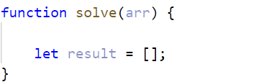
- You can use for loop to go around the items one by one.
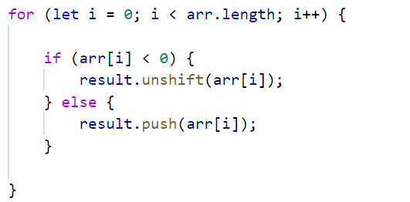
- If the current element is a negative number, you can use the unshift() method to add the number at the beginning of the array.
- Otherwise, if the current element is a positive number (or 0), use a push() method to add the number to the end of the array.
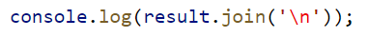
- Print on the console, each element of the array on a new line.

- First and Last K Numbers
Write a function that prints the first k and the last k elements from an array of numbers.
The input comes as an array of number elements. The first element represents the number k, all other elements are from the array that needs to be processed.
The output is printed on the console on two lines. On the first line, print the first k elements, separated by space. On the second line, print the last k elements, separated by space.

Examples
Input | Output |  | Input | Output
[2,  7, 8, 9] | 7 8  8 9 |  | [3,  6, 7, 8, 9] | 6 7 8  7 8 9

Hints
- Use slice() to split the array into two parts
- Last K Numbers Sequence
You are given two integers n and k. Write a function that generates and prints the following sequence:
- The first element is 1.
- Every following element equals the sum of the previous k elements.
- The length of the sequence is n elements.

The input comes as two number arguments. The first element represents the number n, and the second – the number k.
The output is printed on the console on a single line, separated by space.

Examples
Input | Output |  | Input | Output
6, 3 | 1 1 2 4 7 13 |  | 8, 2 | 1 1 2 3 5 8 13 21

Hints
The 2nd element (1) is the sum of the 3 elements before it, but there is only 1, so we take that. The third element is the sum of the first 2 (1 and 1), and the 4th – the sum of 1, 1, and 2. The 5th element is the sum of the 2nd, 3^{rd,} and 4th (1, 2, and 4) and so on.
- Process Odd Numbers
You are given an array of numbers. Write a function that prints the elements at odd positions from the array, doubled and in reverse order.
The input comes as an array of number elements.
The output is printed on the console on a single line, separated by space.

Examples
Input | Output |  | Input | Output
[10, 15, 20, 25] | 50 30 |  | [3, 0, 10, 4, 7, 3] | 6 8 0

Hints
- Counting in arrays starts from 0
- For example –we receive 10, 15, 20, 25
- The elements at odd positions are 15 (index 1) and 25 (index 3)
- We need to take these two elements and multiply them * 2
- Finally, we print them on the console in reversed order
- Smallest Two Numbers
Write a function that prints the two smallest elements from an array of numbers.
The input comes as an array of number elements.
The output is printed on the console on a single line, separated by space.

Examples
Input | Output |  | Input | Output
[30, 15, 50, 5] | 5 15 |  | [3, 0, 10, 4, 7, 3] | 0 3

Hints
- You can use the following function to sort the numbers in the array:
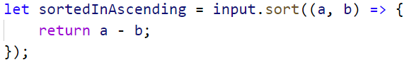
- Afterward the first two elements in the array are the smallest
- You can use slice() to take the first two numbers

- List of Products
You will receive an array of products. Print a numbered array of all the products ordered by name.

Example
Input | Output
['Potatoes', 'Tomatoes', 'Onions', 'Apples'] | 1.Apples  2.Onions  3.Potatoes  4.Tomatoes
['Watermelon', 'Banana', 'Apples'] | 1.Apples  2.Banana  3.Watermelon

Hints
- The sort function rearranges the array in ascending order
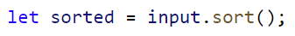
- Finally, we have to print our sorted array. To do that we loop through the array
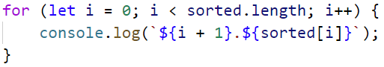
- We use i + 1, because we want to start counting from 1
- Array Manipulations
Write a function that manipulates an array of numbers.
- Add {number}: add a number to the end of the array
- Remove {number}: remove all occurrences of a particular number from the array
- RemoveAt {index}: removes number at a given index
- Insert {number} {index}: inserts a number at a given index
Note: All the indices will be valid!
The input comes as an array of strings. The first element will be a string containing the array to manipulate. Every other command you receive will also be a string.
The output is the manipulated array printed on the console on a single line, separated by space.

Example
Input | Output
['4 19 2 53 6 43',  'Add 3',  'Remove 2',  'RemoveAt 1',  'Insert 8 3'] | 4 53 6 8 43 3
['6 12 2 65 6 42',  'Add 8',  'Remove 12',  'RemoveAt 3',  'Insert 6 2'] | 6 2 6 65 42 8

Hints
First, we receive the whole input:
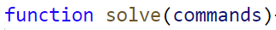
- After that we take the first element from the commands and convert it to an array of numbers:
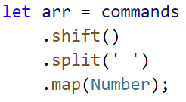
- Then we loop through the commands array, obtain each element from the command, and cast both numbers. This event is called destructuring:
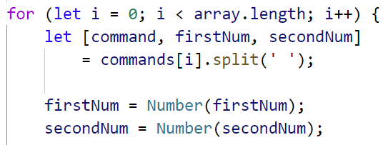
- We check if the command is equal to one of the given: "Add", "Remove", etc. 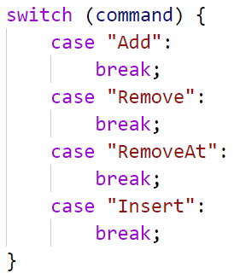
- To add an element at the end, use push()
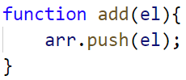
- To remove all occurrences of a particular element from the array, you can use filter()
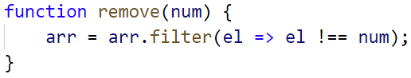
- To remove or insert at an index, you can use splice()
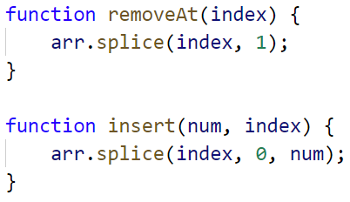
Note: Removing elements with splice() receives two parameters:
- Start Index
- Count of elements you want to remove
Note: Inserting elements with splice() receives three parameters:
- Start Index
- Count of elements to remove – if none enter 0
- Elements to insert at that position

